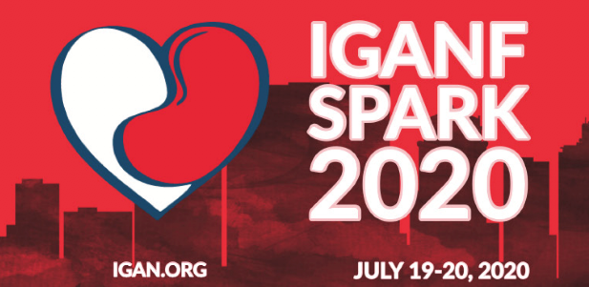

VIRTUAL AGENDA

Wednesday, July 8
7:30pm – 8:15pm – History of IgAN
Dr. Bruce Julian, Professor Emeritus at University of Alabama
8:15pm – 9:00pm – Calliditas

Wednesday, July 15
7:30pm – 8:15pm - What is a Kidney Biopsy?
Dr. Jared Hassler, Renal Pathologist & Associate Professor
at Temple University
8:15pm – 9:00pm – Chinook

Wednesday, July 22
7:30pm – 8:15pm - Be Your Own Kidney Advocate
Alex Berrios, Jr. & Whitney Simmons, BSN, RN
8:15pm – 9:00pm - Retrophin

Wednesday, July 29
7:30pm – 8:15pm – How to Find a Donor Through Social Media & Marketing
Gisela Delgado
8:15pm – 9:00pm - Transplant Process & Living With Your Transplant Q&A
Stuart Miller, Moderator
Patient Panel

Wednesday, August 5
7:30pm – 8:15pm - Thriving Through Food
Emma Ryan, Integrative Health Coach
8:15pm – 9:00pm – Omeros

Wednesday, August 12
7:30pm – 8:15pm - Understanding Your Lab Results
Dr. Dana Rizk, Medical Director for Clinical Trials at University of Alabama
8:15pm – 9:00pm - Alnylam

Wednesday, August 19
7:30pm – 9:00pm - Having Your Donor Find YOU!
Harvey Mysel, Living Kidney Donors Network

Wednesday, August 26
7:30pm – 8:15pm - Caregivers “Self Care: Are You Putting Your Own Oxygen Mask on First?”
Lynn Bartrum, Integrative Life Coach
Maureen Doyle, MAT, Integrative Life Coach
The Estuary, Nashville, TN
8:15pm – 9:00pm – Otsuka/Visterra

Wednesday, September 2
7:30pm – 8:15pm - – Patients “Surviving and Thriving"
Danielle Gilbert, Holistic Health Coach
Jessica Kerske, Integrative Life Coach
The Estuary, Nashville, TN

